

|  |  |
| --- | --- |
|  | Asia Gateway Corporate Services  Your Online Receptionist  Agent Mobile Platform User Guide |
|  |  |

Contents

1. Logging into your Agent Account 3

1.1 Log in 3

2. Understanding Your Mobile Agent Dashboard 4

2.1 Understanding Your Mobile Agent Dashboard 4

3. Understanding Menu Tab 5

Getting Started

Welcome and thank you for choosing online receptionist as your call centre management facility.

By now you would have received your Username & Password, kindly proceed to [www.online-receptionist.com/mobile](http://www.online-receptionist.com/mobile) to login to the call management system.

# Logging into your Agent Account

## 1.1 Log in

1. Enter your **Username** and **Password** provided to you into the Login
2. Enter the dynamic **Security Code** as shown in the figure below.

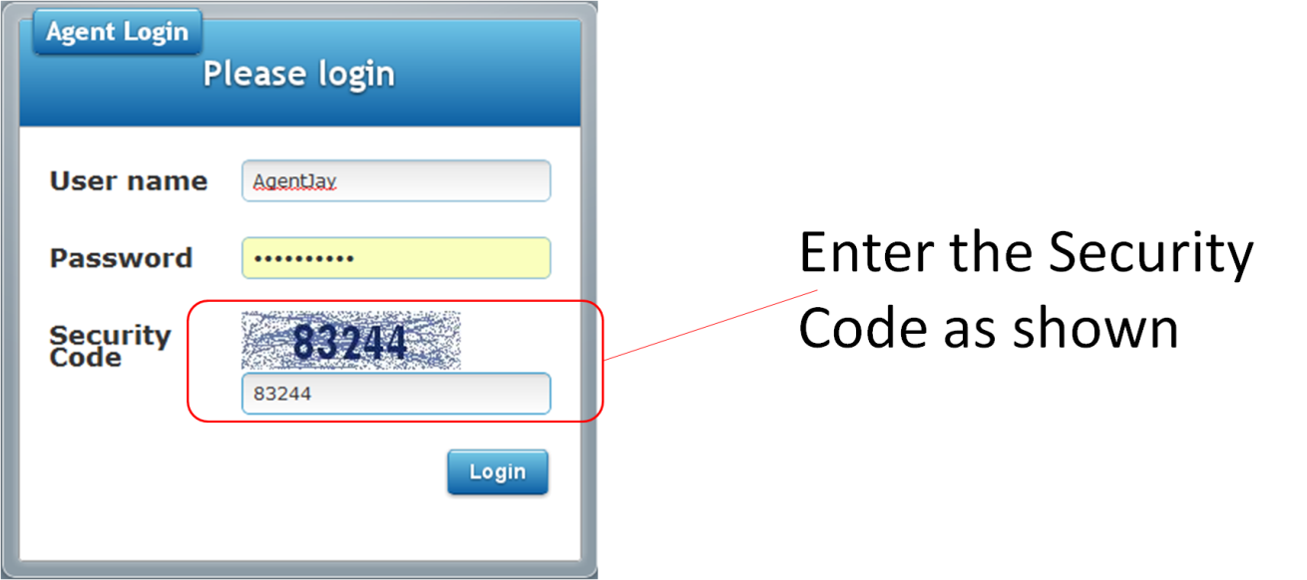

1. Click on the **Login** button.
2. If you have entered a wrong password or username, the system will prompt you to re-enter your correct username and password. Please note that your username and password is **case-sensitive**.

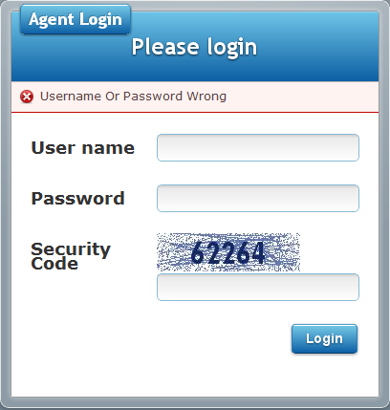

1. Understanding Your Mobile Agent Dashboard

Figure 2a: Mobile Agent Dashboard – Home

## 2.1 Understanding Your Mobile Agent Dashboard

After logging in correctly with your username and password. You will be brought to the **Mobile** **Agent Dashboard**.

The Mobile Agent Dashboard is split into 3 main sections as shown in Figure 2a.

The interactive menu sections each cover different aspects for a manager of a call centre agent requirements .

The following is a quick summary of each of the menu tab functionalities

|  |  |  |
| --- | --- | --- |
|  | **Menu Bar** | This button will allow user to perform one of the following options:   * Home * My Profile * Logout |
|  | **FAQs UI:** | This section will display Frequently Asked Questions, and can be referenced as a knowledge base.   * New questions can also be posted to the system and assigned to a staff member for an answer. * Users can also look up for an existing question using the search functionality. * Managers can also respond to Open Questions with answers. |
|  | **Ticket UI:** | In the event, when a caller has dialed into the call centre for an issue to be resolved, a ticket will be raised by the call agent. Managers who have access to this mobile platform, can closed out tickets assigned to them. |

# 3. Understanding Menu Tab

**Figure 3a: Menu options**

When a Team member clicks on the Menu button, they are brought to the following options.

* Home
* My Profile
* Logout

3.1 Selecting the Home option, will bring the user back to the previous UI.

3.2 Selecting My Profile option will allow the user to edit their contact details. (Refer to Figure 3b).

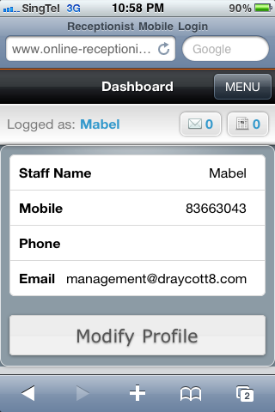 **Figure 3b: Modify Profile UI**

* 1. Selecting **Logout** option will allow the user to exit the Mobile Agent Dashboard.